World Will Get Wilder & How the Enemy Sabotages
September 04, 2026
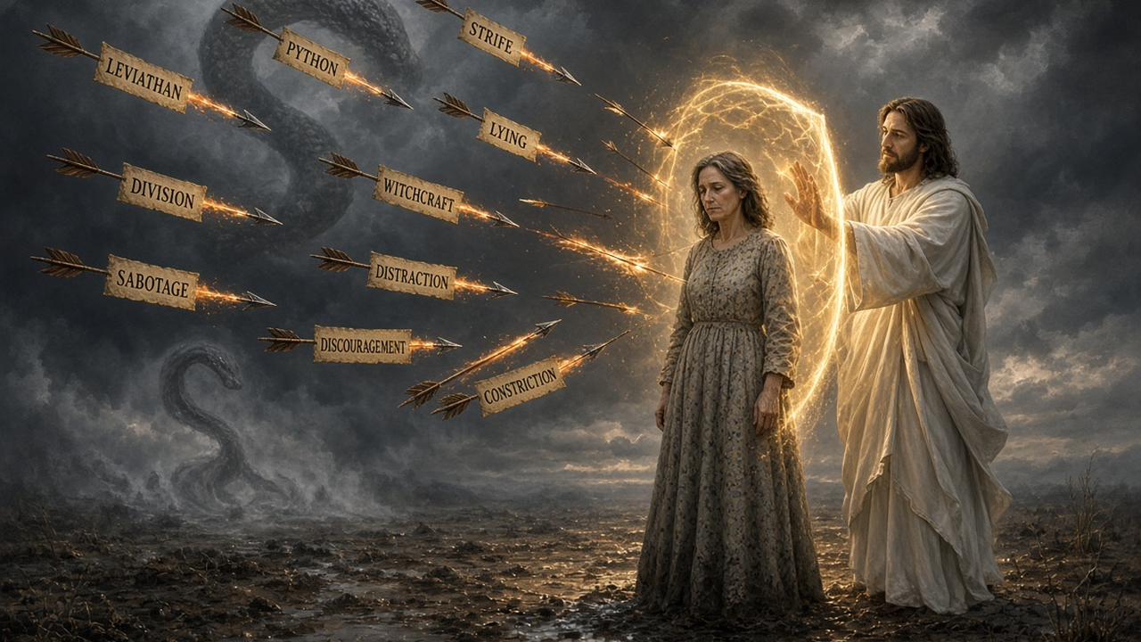
May the sweet presence and reassurance of our Savior be with you. Dear family, Jesus is watching over you and directing your Steps every moment of the day. Please don't Let that awareness slip by you. Heartdwellers, be aware of distractions the enemy Sends into your day, especially contentious ones or Complicated issues that are going to take a Lot of your time to resolve.
Clearly they Are from the evil one, to slow us Down, drain our energy and cause discouragement. We have been sabotaged in this area for Quite a long time and I'm trying to Streamline the messages so you'll get them on Time. The enemy has been making mountains Out of molehills to complicate and steal our Creative energy and our ability to reach souls.
For the Lord, Don't let him do it. The Lord warned me that it was Leviathan: Twisting, misrepresenting and pushing people's buttons. This principality is famous for taking innocent situations And turning them into conflict. Python is Also involved: to suppress our progress, drain us Of strength and inspiration- basically, Sabotage.
And make walking through this mess like Being in mud up to our waist Waste. Now that we know what it is, we Can fight it. The assignments are also sealed By the witches, so we first must break The seal on the assignment, then break the Assignment, then seal that strategy with the precious Blood of Jesus.
These tensions have been Going on for weeks and it is only Just now that we finally had the strategy To stop them. If you just bind or Commend the demons of strife, lying division, they Just replace the demons. There's plenty of demons At their disposal to do that. But if You destroy the assignment, there's nowhere for the Demons to operate until they they launch another Assignment.
And many times these assignments are launched With a special day, like the full moon Or whatever, and they're not that easy to Put back up. So I highly recommend you Do the 14 -day protocol they teach on The Dark Crossing channel. I also would like To give you a heads -up. That after Mass or after consecration, when you receive the Lord, the veil comes down many times and You can begin to communicate with him.
You Can hear him more clearly. So I encourage You to have mass in the morning and To receive him. In fact, the Lord has Asked us to have two masses a day And a rosary for our nation, And that's Up to you if you think you can Do that. But it's important to him, important Enough that he told me about it.
All Right, moving on with the message, I received the Lord in communion and he Appeared to me immediately. He said: I'm right Here, my love. I've been here all this Time listening to your prayers and taking note. You could please me greatly by having two Masses for your country and the rosary every Day.
I know it feels sometimes monotonous, But that doesn't matter. You are still fulfilling My wishes and connecting with my mother. Even When you don't feel inspired, I'm always here, Beloved, I'm always near and working in your Favor. Together we can conquer your sin nature, The one that so grieves you.
And here He's talking about my battle with food. Even Though my weight is normal, I still love Food, especially good food, especially chocolate. Anyway, I have a battle with self -denial and Food on stressful days and around the full Moon, which they usually coincide together. So He's helping me with that and I'm seeing An improvement, But it isn't easy And it Is a sacrifice.
That is releasing Graces and going to those who are in Dire straits right now, like Nepal and Argentina and different places around the world. So Even when you struggle and when you make A sacrifice, it's like simon's cross- there are Graces released.
Okay, Jesus continued. Things are going to get wilder and more Difficult in the world.
You will ride it Out in the vessel of my grace. This Is not something you can survive on on Your own Heart dwellers. You must stick together, Buried in my heart, Listen to my messages, Make resolutions and do all that I put Before you to do. The enemy will hit You hard with the temptation to give up On key relationships or projects.
He is Plotting ways to separate best friends 24 -7. He does that for sure. Your Support system, those who work with you, your Husbands and wives, families, are targets. So when difficult circumstances seem- and I do Mean seem- or appear to be threatening, You both stick together, humble down and get To the very bottom, bottom of the conflict.
Don't just settle with a smile and I Forgive you. Dive deeper, See the strategy, Stay alert. Don't settle for superficial reasons. Both of you need to dig deeper, Know Yourself, Know yourself and know your enemy. Because you are dwelling in my heart with The a firm resolve to serve me.
I Will instruct and keep you. Only be very Careful to do all I ask of you. If you miss one or two things, it Will affect you negatively. And here I want To take a break and say there are Times when I've in the past, when I've Been lazy and I said, oh, it won't Matter, I and get it up tomorrow, getting A message up, and how wrong I was.
So I'm correcting that bad behavior. It's really Sloth, Okay, moving on with what Jesus was Saying. He was saying: if you miss one Or two things, it will affect you negatively. That is why I'm very careful to instruct You. These are not just nice messages. This Is your lifeline As you are learning to Hear me clearly and fend off those who Would like to divert your attention, seducing you With things that appeal to you but are In no way my will for you.
Beware Of Python witchcraft. Beware of Python, Of every event in your day that interferes With you moving forward. Python witchcraft is Constricting, Stopping forward motion, And I have to Say there are some symptoms in your body That are also an indicator of python witchcraft: Constriction in your throat, difficulty speaking.
Those Things are signs that python is. At work And that can be broken off of you And you can be restored to the full Use of your throat. That's what I'm working On right now, so that I can sing Again. Constriction is python's method of oppressing Us. Anytime you feel any kind of constriction, Even an assignment, have you ever had an Inspiration and it was just so clear cut You knew exactly how to go about it And several hours later it was gone?
That Is the kind of thing that python witchcraft Does: it steals and dampens down your inspiration, Making it seem like it wasn't an inspiration At all. So you'll abandon it. Beware of That, dear ones. Do not allow the enemy To delay you or take you off course. Triple check with me to make sure you Are headed in the right direction.
Take nothing For granted. The enemy is slick and knows How to mislead you. Clare, this soon will Be over. It is the Muslims and other Unsaved people groups that I am deeply concerned About. Focus your prayers there and steadfast Reliability in your walk with me, Ignore the Fiery darts of the enemy.
Lord, you Once told me that you were giving me an iron will so I would not waver, But stand up to the storms and survive. He answered: Yes, in so many words. I Did. Well, what has happened to change that? I have taken you through a cycle of Deep humility. Humility so some of that protection Is no longer there, but I will again Fortify you as you walk in obedience and Humility.
This is all I'm asking of you, And I never ask of you without also Equipping you to function in that assignment. I know how weak you are and I Know how you're feeling beloved. I know it Seems impossible for you, because it is. You cannot do any of this without full Reliance on me.
Do not allow a day To pass without us sitting down together and Connecting so that you will be prepared for That day. Then I had another Mass In the evening and Jesus again began to Speak to me. Little one, yes, you are My little one- become littler and littler each Day, just the way I like you best.
So very, very little. When you Celebrated mass just now, you were so little, So vulnerable, so very careful, wanting to do It justice, justice, and yet, by men's standards, You are not fully trained to do it That way. Yes, your way is by the Heart. Always remember that clear. Most Of all, I want your heart in the Mass.
The words mean nothing if the heart Is absent. So do not stress yourself to Get it perfect by the book. Pour your Heart into it for the sake of souls, And I will be very happy indeed. Linger now with me. I am transforming you, Clare. You are becoming a new creation each Time you reverently celebrate the Mass, And you Are also being transformed on the inside.
Little One- Yes, I like that name- Little. Become Even littler, since that is what pleases me Most: The Mass is a family affair. Your Heavenly Father, your Holy Bridegroom, the most Holy saints and angels, brothers and sisters, Oh My, what a wonderful place to sing my Praises and enter into the inner sanctuary, Tucking Your soul under my shoulder, close to my Heart, And removing all that does not belong In our hearts of love.
And then I Cried out to Our Lady and I said: Oh sweet Mother of God, how very sweet You are. Please help me to do a Better job of spreading your devotion and bringing All mankind to the table of their eternal Family. Let not even one be stranded or Left out. Oh, my beloved Jesus, I cannot Say goodnight to you.
I must take you With me and curl up under your arm, Beside you. He replied: No need To say goodnight, my dove. No need to Ever say goodnight or goodbye because I never Leave your side. Comfort me, Clare, Lord. I feel so inadequate to do such A thing. How can I comfort you, Jesus?
Jesus, love on me and make excuses for All those who are indifferent and do not Know me. Convince me that you will pray For them to finally receive me, Ask for The graces necessary to bring me to them In such a way that they will recognize Me and be smitten by my love for Them.
And that was the end of his Message.
Oh, he has such a tender heart. Dear ones, let us try not to grieve His heart and let's pray for the ones That don't know him yet. It's so, so Important to him. Thank you for being A support to this channel and for listening In. God bless you until the next time.

